Name: Shaunak Deshpande

IC C

Roll number: 04

GR Number: 11911180

Lab-

**Strings**

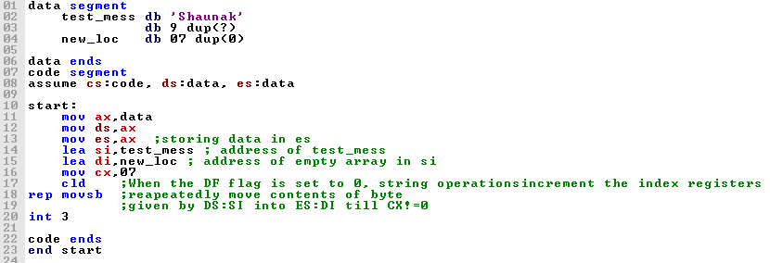

**Output:**

**Before:**

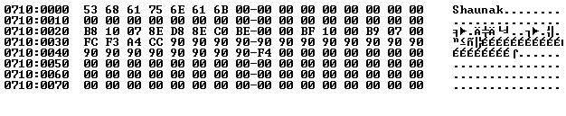

**After:**

